OpenCV rotation function mapping

Kabir Chhabra : Diploma Business Analytics

Abdul Akram Shaik : Masters in Quant fin

#### **Abstract:**

***This report outlines the approach taken to address the problem statement of mapping angles reported by the*** *minAreaRect()* ***function in the OpenCV library to the actual orientation of objects in an image. The*** *minAreaRect()* ***function reports angles only between 0 and -90 degrees, making it necessary to establish a mapping between these reported angles and the actual orientation of objects rotated from 0 to 360 degrees. Our approach involves generating synthetic data for rectangles of different sizes rotated randomly and capturing the angles reported by*** *minAreaRect()* ***along with the coordinates of the other three vertices. This data will serve as the basis for developing a mapping or function that accurately translates the reported angles to the true orientation of objects.***



#### **Introduction:**

The problem statement revolves around the discrepancy between the angles reported by the minAreaRect() function in the OpenCV library and the actual orientation of objects in an image. This discrepancy arises due to the way minAreaRect() assigns angles to the sides of the minimum bounding rectangle, with the bottom-most vertex being labeled as 0 and subsequent vertices numbered 1, 2, and 3 clockwise. To address this issue, our project aims to establish a mapping or function that correlates the reported angles with the actual orientation of objects rotated from 0 to 360 degrees.

**Methodology:**

The approach taken involves the following steps:

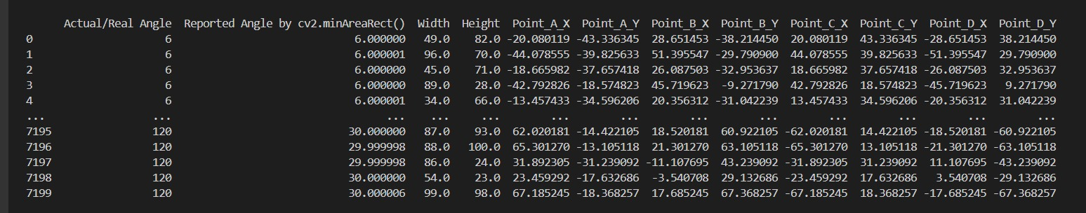**Generation of Synthetic Data**: Rectangles of varying sizes are generated, and each rectangle is rotated randomly from 0 to 360 degrees. For each rotated rectangle, the angle reported by the minAreaRect() function is captured, along with the coordinates of the other three vertices relative to a fixed vertex around which the rectangle is rotated.

**Data Collection**: Synthetic data consisting of the reported angles and corresponding object orientations are collected for a range of rotated rectangles.

**Analysis**: Statistical analysis is performed on the collected data to identify patterns and relationships between the reported angles and the actual object orientations.

**Mapping Function Development**: Based on the analysis, a mapping function or algorithm is developed to accurately translate the reported angles to the true orientation of objects.

**Results and Discussion:**

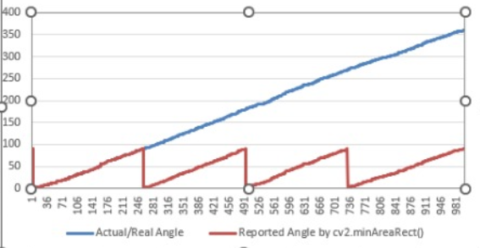

Preliminary analysis of the synthetic data reveals a complex relationship between the reported angles and the actual object orientations. While the reported angles exhibit a limited range (-90 to 0 degrees), the true orientations span the entire 360-degree range. Developing an accurate mapping function requires careful consideration of these factors, including potential nonlinearities and discontinuities in the mapping.

**Conclusion:**

The approach outlined in this report provides a systematic framework for addressing the problem of mapping angles reported by the minAreaRect() function to the actual orientation of objects in an image. By generating synthetic data and analyzing the relationship between reported angles and object orientations, we aim to develop a mapping function that enhances the accuracy of orientation estimation in computer vision applications.

**Future Work:**

Future work will focus on refining the mapping function using advanced statistical techniques and exploring alternative approaches, such as machine learning algorithms, for angle-to-orientation mapping. Additionally, real-world testing and validation of the mapping function will be conducted to assess its performance in practical applications.

**References:**

[1] OpenCV Documentation: https://docs.opencv.org/  
[2] Python Documentation: <https://docs.python.org/>

[3]<https://forum.opencv.org/t/rotate-the-bounding-box-of-object-detection-and-crop-it/7949>

[4]<https://stackoverflow.com/questions/61718596/how-to-rotate-bounding-box-in-open-cv-and-crop-it-python>

[5]https://stackoverflow.com/questions/59651764/python-opencv-how-to-calculate-angle-of-object-wrt-a-sample

**The template is designed for, but not limited to, six authors.** A minimum of one author is required for all conference articles. Author names should be listed starting from left to right and then moving down to the next line. This is the author sequence that will be used in future citations and by indexing services. Names should not be listed in columns nor group by affiliation. Please keep your affiliations as succinct as possible (for example, do not differentiate among departments of the same organization).

### For papers with more than six authors: Add author names horizontally, moving to a third row if needed for more than 8 authors.